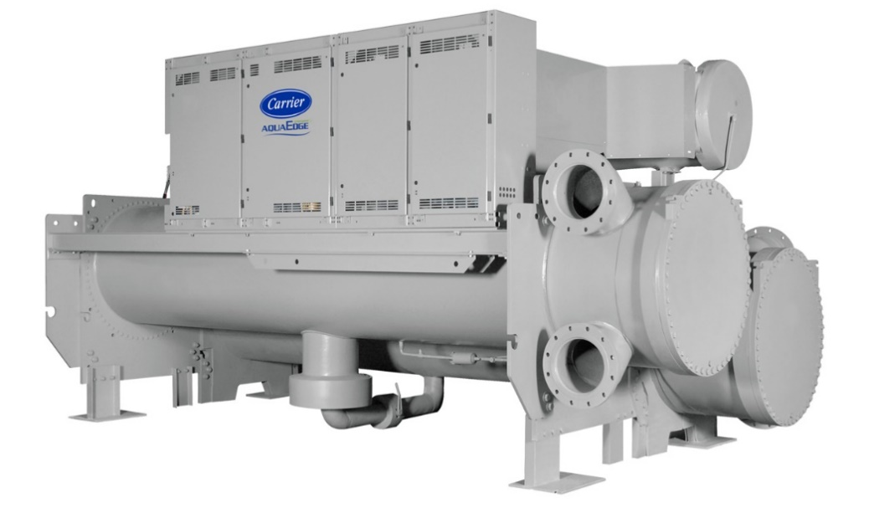
Device Information
Chiller Number | 4998J59038
Location Name | 811 10th Ave-811 10th Ave
Location City | New York
Postal Code | 10019-5042
Site Address | 811 10th Ave
Time-zone | America/New_York
Year of Manufacturing (Age) | 1998(26 Years)
Model Number | 19XR-6765465DFS64-
Report Duration | 2023-01-06 ~ 2023-08-15
Chiller Run Hours | 53,469

Summary
As part of Carrier’s connected chiller program our command center experts continuously monitor performance and health of your chiller and its major components to provide real time feedback and less operational disruption.
Your chiller serial number 4998J59038 was evaluated for Chiller Replacement Analysis. Further Analysis is performed from the real time data from 2023-01-06 to 2023-08-15. The design efficiency of current chiller is 0 kW/T. The overall efficiency of this chiller is 0.53 kW/T. Replacing this with a Carrier Aqua Series Water Cooled Chillers can improve the overall efficiency to 0.41 kW/T. This replacement can improve the chiller efficiency by 23%. The chiller is running at low loads (<60% RLA) for 50% during the analysis period and this replacement can enhance design integrated part-load values (IPLV) to as low as 0.37 kW/T.
Chiller Replacement Benefits:
- Improved Efficiency
- Reduces operating expenses.
- Easy to maintain.
- Quiet operation
- Reliable operation
- Environmentally sustainable refrigerant
- ASHRAE 90.1 compliant
- High-efficiency optimization
- Diagnostic controls
Based on the performance of the chiller operation versus measured parameters, Carrier recommends further evaluation of the Chiller Replacement by our certified technician. This will ensure optimal performance of the Chiller.
Alarm/Setpoint Analysis
There are no alarms during this period.

The analysis result show that setpoint not meeting 1% of time.
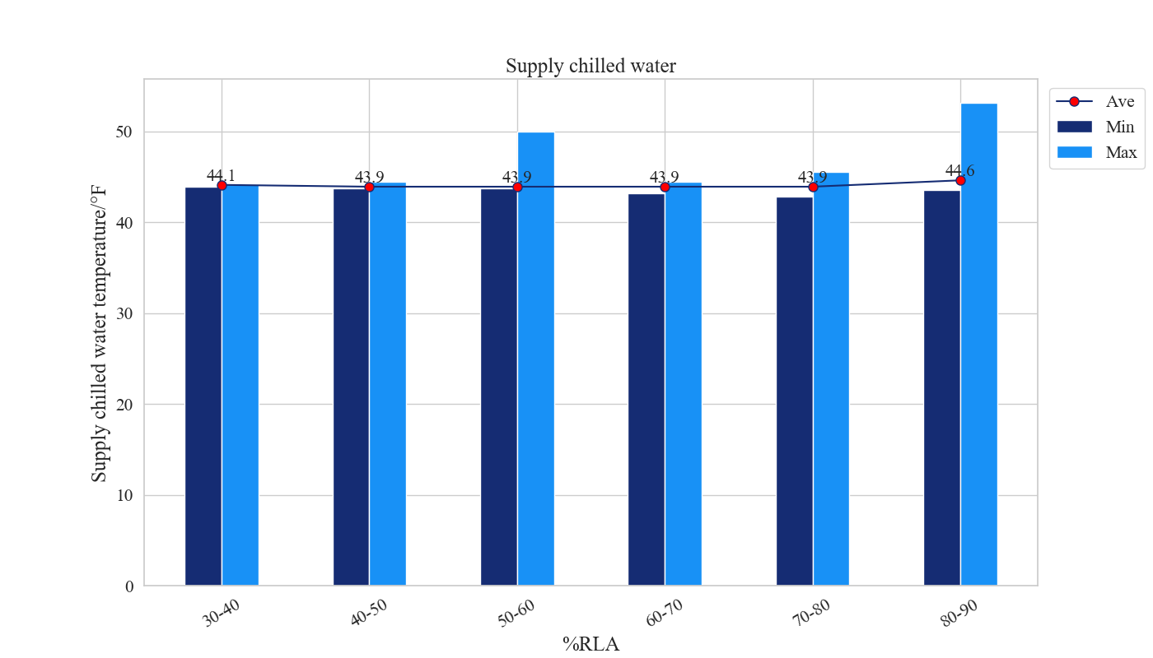
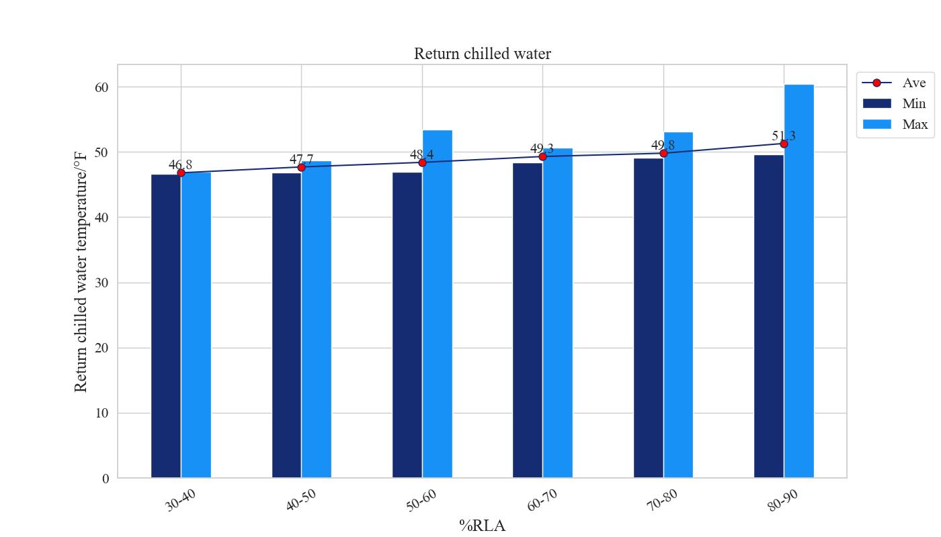

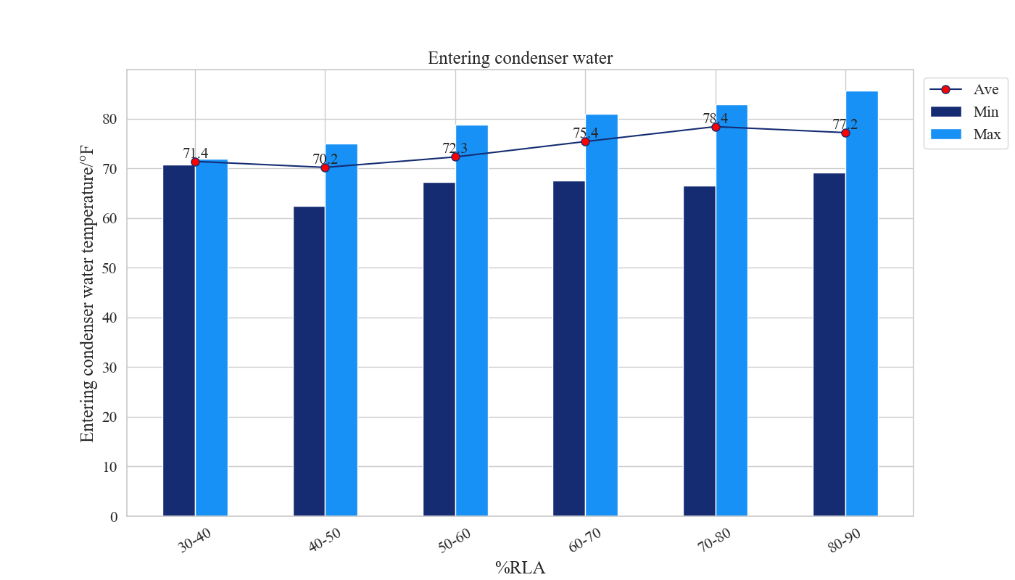
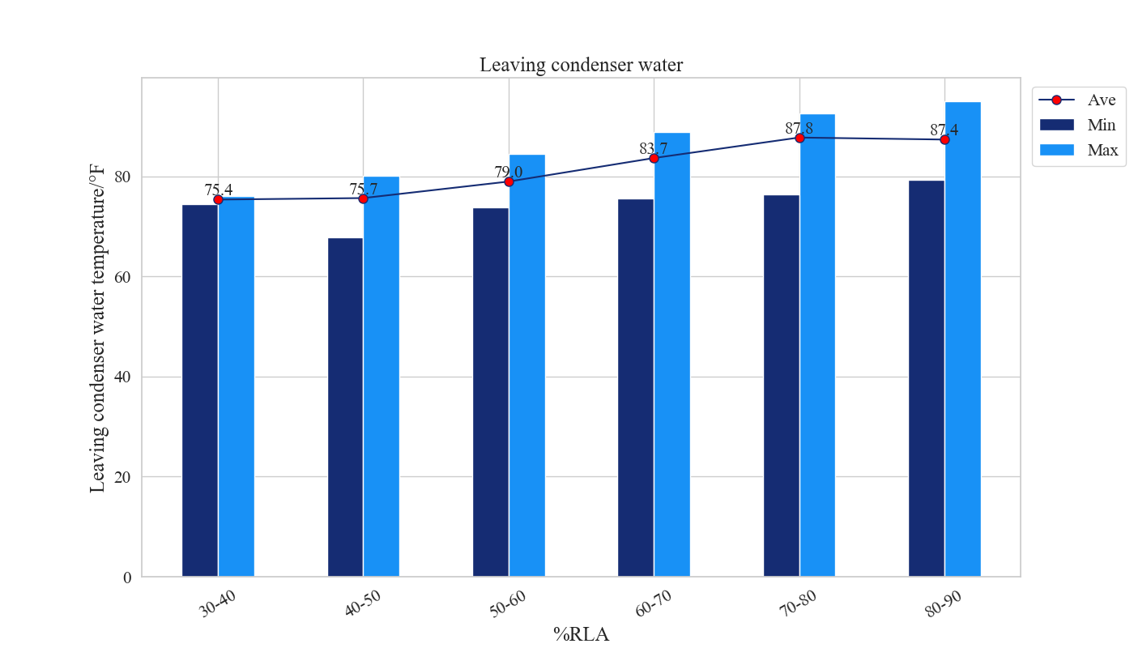
Comments
The Average Cooler supply water temperature is between 43.9 to 44.6 (°F) and the average Condenser entering water temperature is between 70.2 to 78.4 (°F).
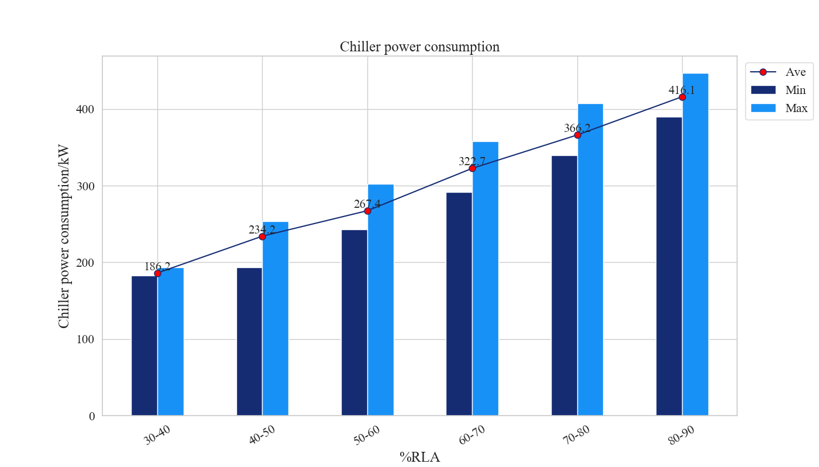
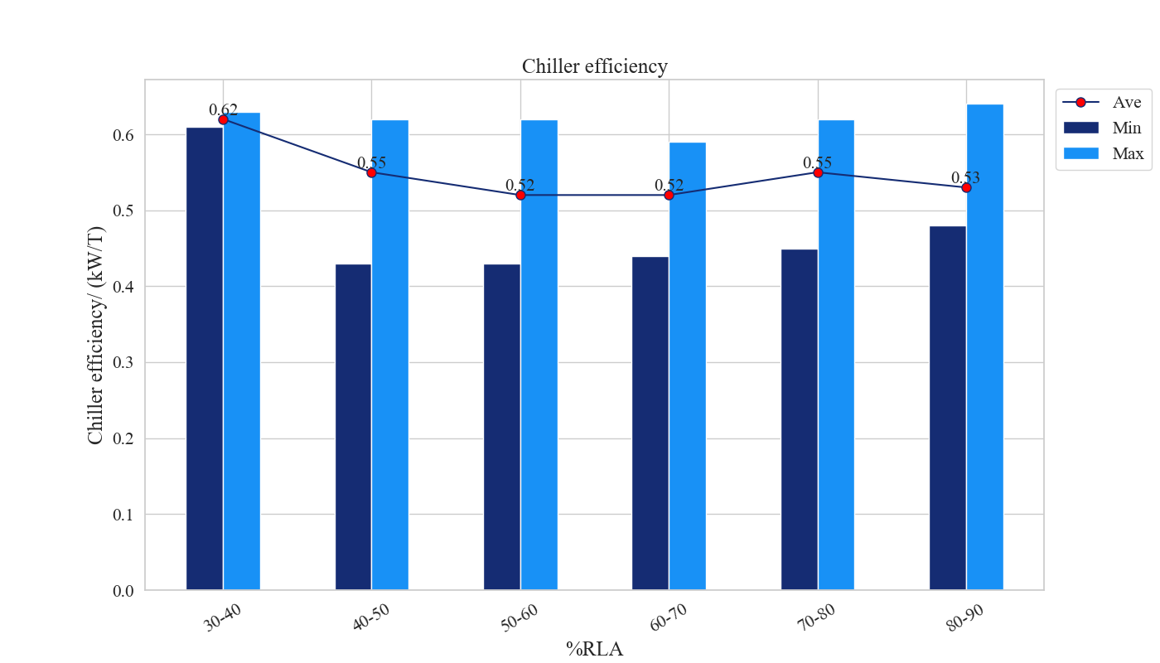
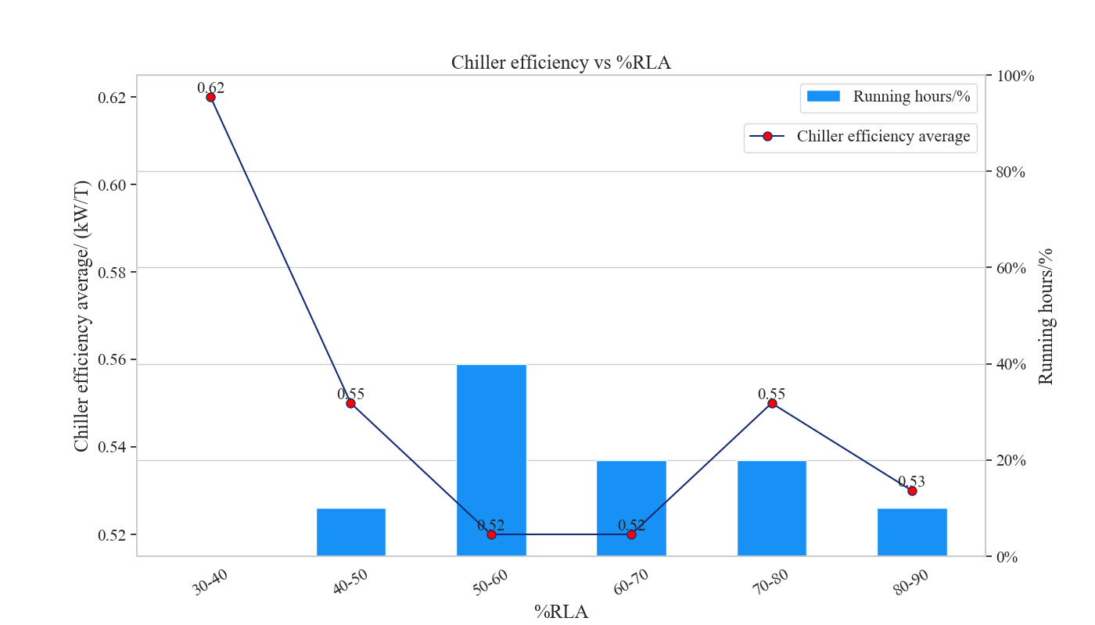
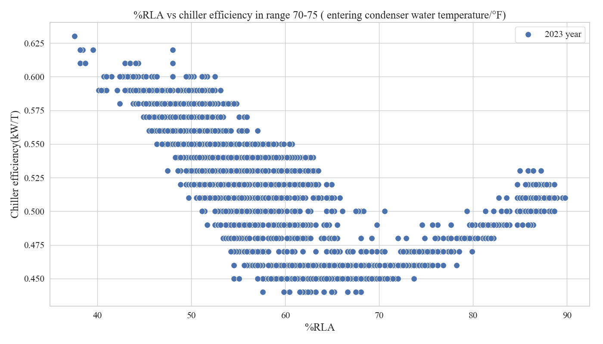
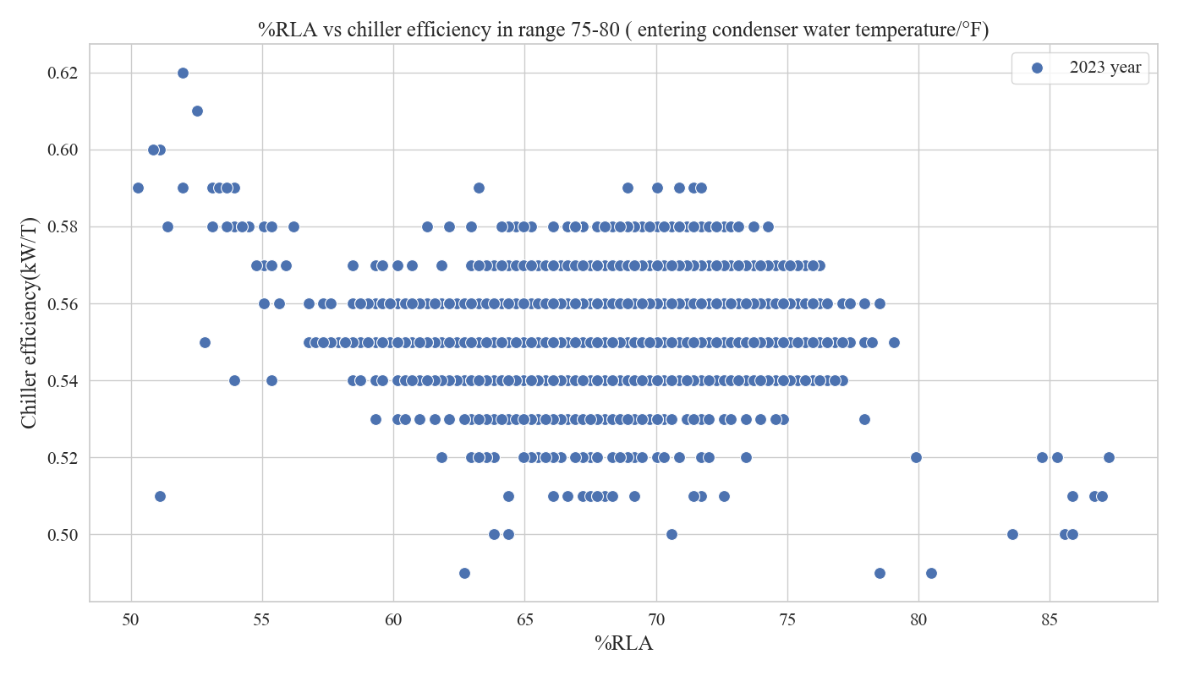
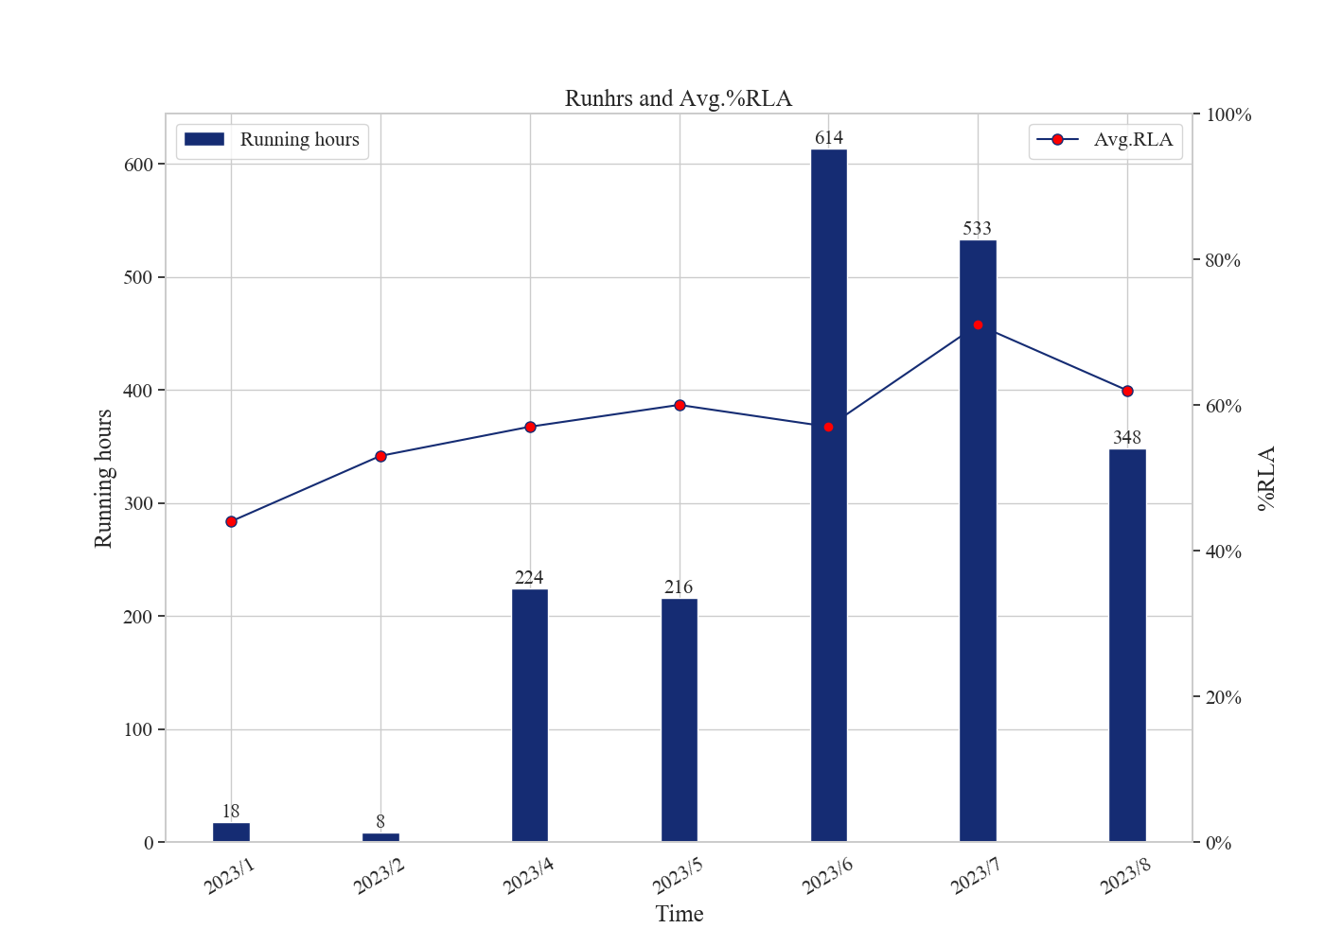
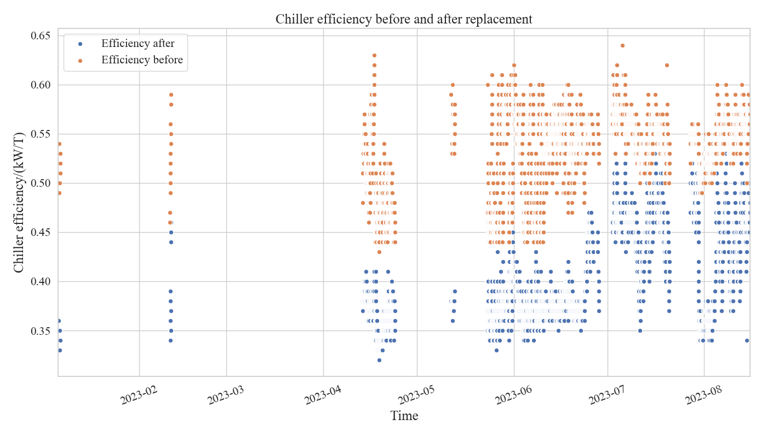
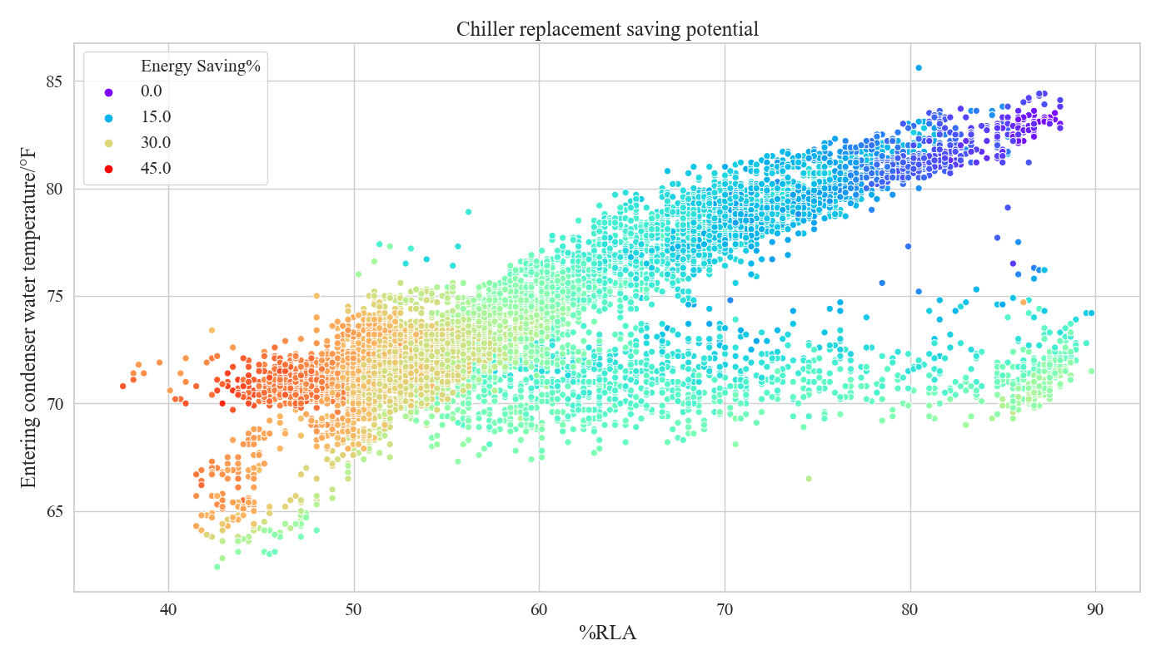
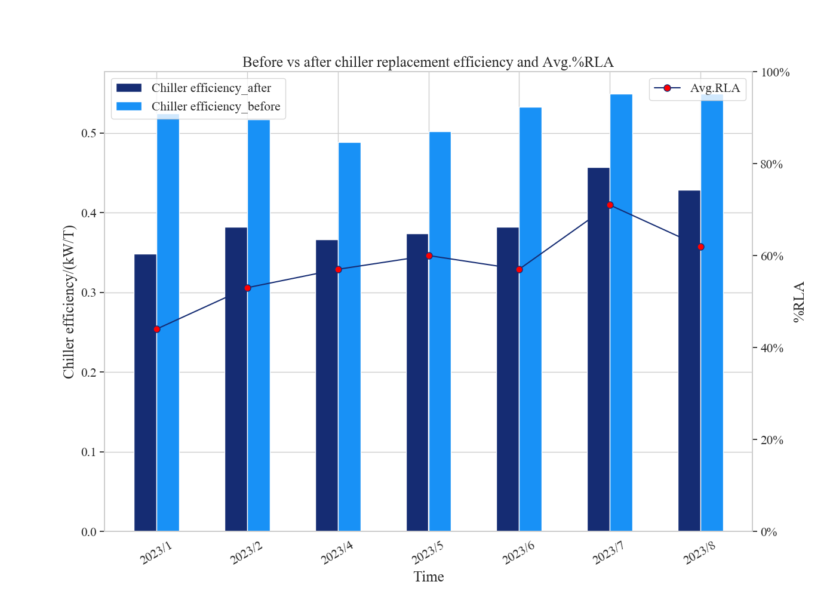
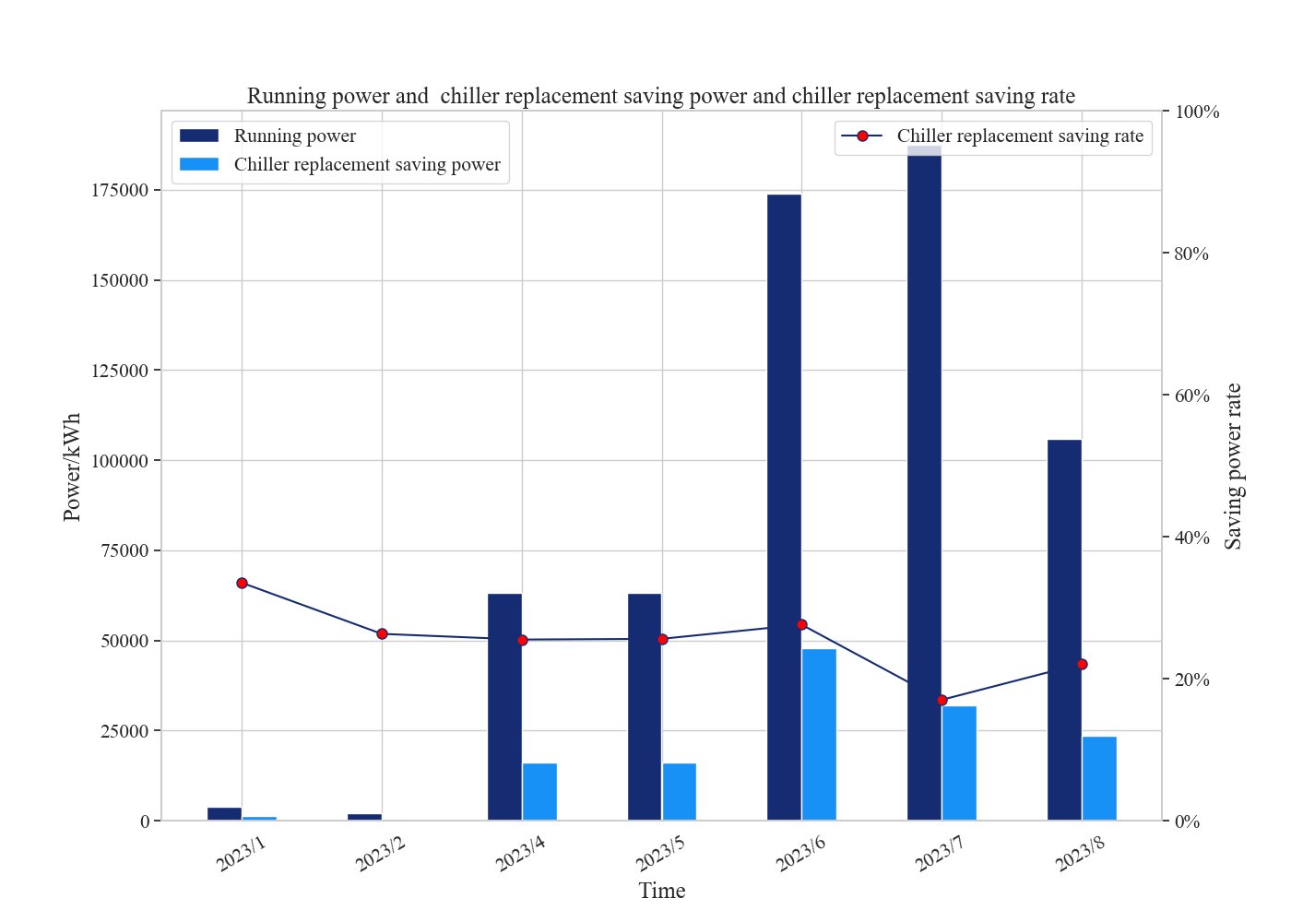
Chiller Sub System Health

Chiller # |  | Condenser Health (Good/Stage of Degradation) | Evaporator Health (Good/Stage of Degradation) |  | Compressor Performance (Good/Stage of Degradation) | Ref leak (Good/Stage of Degradation) | Condenser Water Flow Issue (Yes/No) | Evaporator Water Flow Issue (Yes/No)
4998J59038
S1 | No action required
S2 | Plan to clean/fix
S3 | Clean/Fix immediately
S4 | -
Summary
Energy Efficiency Improve | 23%
Energy Savings | 137,469 kWh
Energy Savings/per year | 227,042 kWh
Investment pay-back period | 10.3 Years

